ABOUT SCOREBOARD with 2 button this is working
================
I want a button In my about page This button should name 'install-PWA'
this Button will allow the user to download pwa version,
this Button shoud be on the same line as 'check for updates
PWA: Service Workers for offline caching and home-screen installation.
How can I make this available When a user is on my GitHub site
I want this To be a stand-alone That is available when the
players got no internet At all times
Explain how you'd Implement a fix for this?
Let me know what file you want me to upload when you are ready?

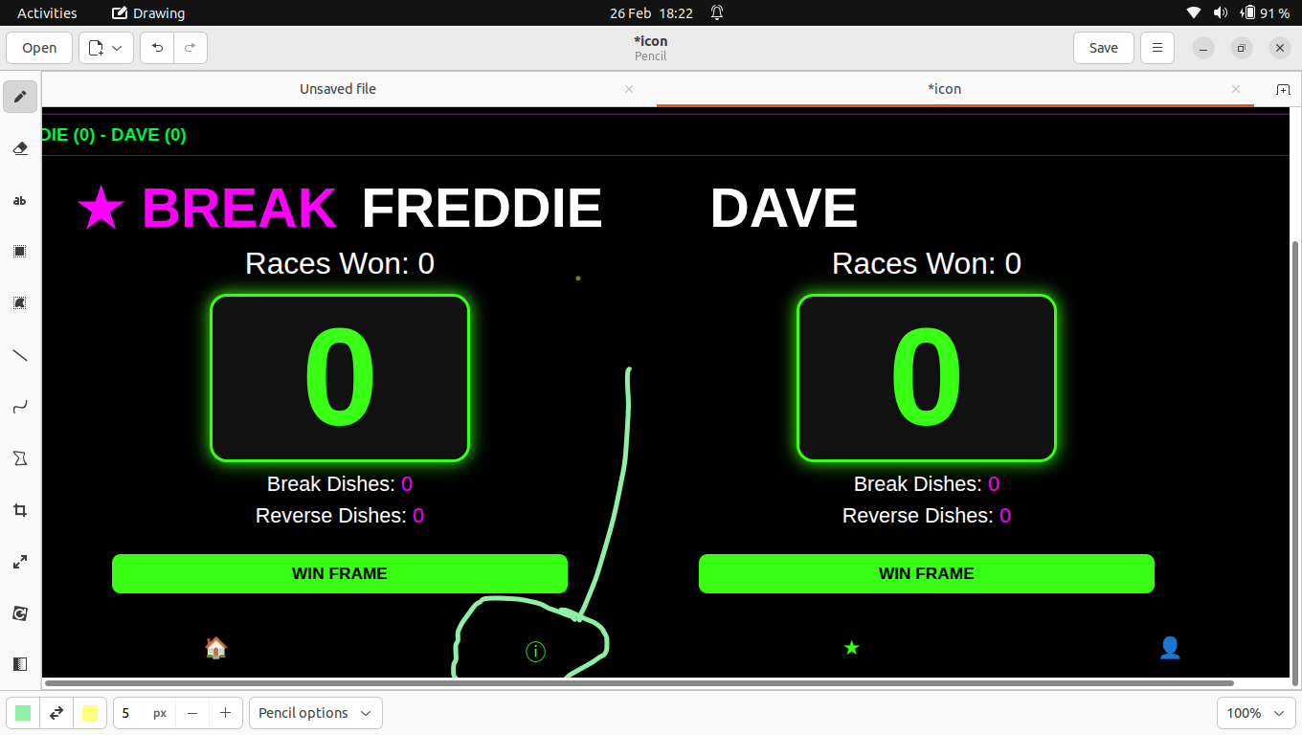

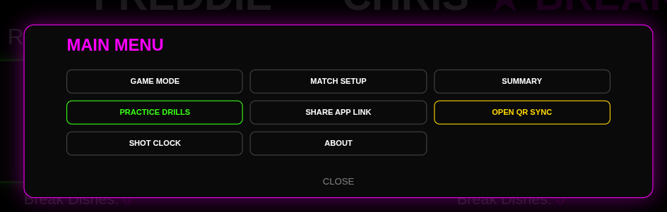
==============================
ok that good

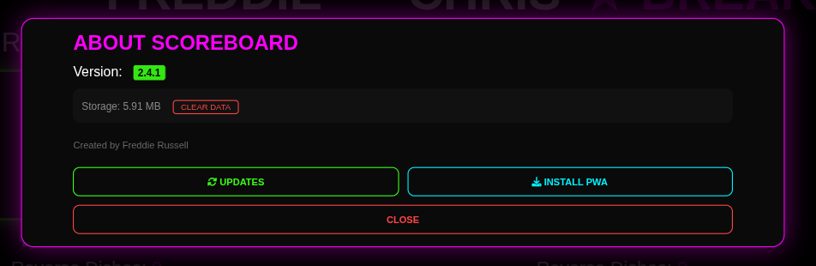
=========version 2.4.1-with 2 button this is working.zip=======

I want to have a dialog box that pops up
when you click this button
<span class="nav-icon star-icon">★</span>
name of 'VIEW PROGRESS'
this will LOG all the frame history that has player,
the log should look same as this?

╔════════════════════════════════════════════════════╗
║ HAPPY4U MATCH PROGRESS LOG ║
╠════════════════════════════════════════════════════╣
DATE: 26/02/2026, 11:35:44
DURATION: 00:01:23 (HH:MM:SS)
RACE TO: 3
------------------------------------------------------
LIVE SCORE: JACK (0) - DAVE (0)
RACES WON: JACK [0] | DAVE [0]
------------------------------------------------------
PLAYER STATISTICS:
JACK [DISHES: 0 | REV: 0]
DAVE [DISHES: 0 | REV: 0]
------------------------------------------------------
MATCH PROGRESS LOG:
[✔] FRAME 1 | WINNER: JACK | TYPE: NORMAL
╚════════════════════════════════════════════════════╝
GENERATED BY Freddie Russell

=====index.html ==add ===script.js===========
To add the VIEW PROGRESS log, you need to update two files: your index.html (to add the popup window) and your script.js (to handle the logic for the ASCII box and time tracking).

My Understanding
- The Look: We are using a <pre> tag with a monospace font. This is the only way to ensure those box characters (╔═══╗) align perfectly like a real computer log.
- The Logic: I've added a "Start Time" variable that triggers the moment the page loads. The log calculates the difference between "Now" and "Start" to give you that 00:01:23 duration format.
- The Trigger: I added an ID (view-progress-btn) to the star icon in your footer so the code knows which button opens the log.
======================================

Put my mower over the bottom bar I see nothing Is there a way that they could show you That it's visible and clickable
<span class="nav-icon star-icon" id="view-progress-btn">★</span>

====================
what file do you need to upload
explain your understanding?

=======My Understanding
My understanding of your request is centered on User Feedback and Convenience:
- The Problem (Visual): Currently, the bottom bar feels "dead." When you move your mouse (or "mower") over the Star icon, there is no visual change, making it feel like a static label rather than a button.
- The Problem (Functional): As the match goes on, the progress log gets very long. Opening it and seeing the start of the match is annoying because you have to scroll down to see the latest frame.
- The Solution: 1. We use CSS to make the star react (turn cyan, grow in size, and glow) as soon as the mouse touches it. This proves it is clickable. 2. We use JavaScript to calculate the height of the text log the instant the window opens and "flicks" the scrollbar to the bottom automatically.

How to apply the "Clickable" fix
Open your style.css file and paste this at the very bottom. This is what makes the star react to your mouse:
============
here is this the only file I need to update?
I'm not sure where to put this code
here is my index.html that is working well, note do not break my code
Only can you have the update code that I required to do this include
the full code I just want to copy paste and tests
show me where you added the new code
explain your understanding?

================================

Is this the only file I need to update?
No. You must update both:
- index.html: To add data-tooltip="MAIN MENU" to the icon.
- style.css: To add the instructions that make the box pop up and glow.

I'm not sure where to put this code
here is my style.css that is working well, note do not break my code
Only can you have the update code that I required to do this include
the full code I just want to copy paste and tests
show me where you added the new code
explain your understanding?

==============================================
I'm not sure where to put this code
here is my style.css that is working well, note do not break my code
Only can you have the update code that I required to do this include
the full code I just want to copy paste and tests
show me where you added the new code
explain your understanding?
=================================

For the 2026/27 season:
Players will contribute £3 per player, per League/Division matches
Applies to the 11 League matches (if divisions of 12)
Cup matches will not be charged
Matches will have a 3-hour time limit
Why is this being introduced?
Over the past season, it has become clear that table usage during Singles League matches has been extending beyond
match play itself. This includes extended practice time, continued use after matches finish, and the biggest issue
has been reserved tables not being used.
While we understand that league matches are social as well as competitive, this has had an impact on the venue’s
ability to operate efficiently, especially during busy periods.
Bar 8 supports the Singles League and provides dedicated playing space throughout the season. The small match
contribution helps ensure the club is fairly supported and that league nights remain viable long-term.
Jamie and I believe this approach is a balanced solution that allows the league to continue growing while
also respecting the venue.
🏆 Tier Structure & Inter-Divisional Cups
Each Tier will again be randomly drawn at the start of the season
Every Tier will have its own dedicated Cup competition
£10 from each entry fee will fund these Inter-Divisional Cups
Top 4 places will be paid
This continues to provide additional competitive opportunities, particularly for players in Divisions 2, 3 and 4 —
giving a 4 in 36 chance of earning prize money outside of their league position.
🆕 New Player Policy
All new players entering the Singles League — regardless of playing history — will begin in the bottom tier
and work their way up.
If entries increase significantly, additional divisions may be created within the tier structure.
💬 2025/26 Fee Allocation
As communicated last season, the additional fees collected during 2025/26 contributed towards:
Table re-cloths
Inter-Divisional Annual competitions
We appreciate everyone’s support in helping improve playing conditions.
💰 Prize Money
All prize money will remain the same for the 2026/27 season.
If you require a copy of the prize breakdown spreadsheet, please get in touch and it will be resent.
📅 Important Information
Entry Deadline: Friday 10th April 2026
Entry is now live:
👉 https://rugbyanddistrictpoolleague.leaguerepublic.com/registrations.html
Entry is confirmed once payment has been received. If you have any concerns regarding payment,
please contact me and we can discuss options.
🏦 New Bank Details – Please Use These
Account Name: Rugby and District Bar 8 Singles League
Sort Code: 30-54-66
Account Number: 32928268
Please ensure you use the correct new bank details when making payment.
We appreciate everyone’s continued support of the Singles League. These changes are
intended to keep the competition strong, fair, and sustainable for the long term.

